**Notes to authors of papers for OIPEEC 2024**

1. Length of full paper: suggest typical length 10-15 pages including figures, tables and references, any paper over 18 pages will be requested to be shortened;
2. Section 8 “Author introduction”: the authors are strongly encouraged to add a short paragraph to introduce themselves to readers and audiences, but this item is not mandatory. The authors also have the option to choose text only introduction without providing photos;
3. Please remember to sign “Copyright Transfer Agreement” and send it back to the editor together with your paper.

|  |  |
| --- | --- |
| Documents management (OIPEEC Committee Use Only) | |
| No | JWD5 |
| Version and date | V2, Oct 23 |
| Confidentiality | Not required |
| Revisions | From version 1, changed header to “Lake Garda, Italy – 2024”  From version 2: two types of reference formats allowed and corresponding author with email added |

|  |  |
| --- | --- |
| Name of Authors (Style: Author, Bold, Arial 12, [1] for corresponding author and email in footnote)) | ODN XXXX |

Affiliation (Style Normal, Arial 12)

TITLE OF PAPER (Style: Paper Title, Bold, Arial 14, ALL CAPS, Central)

Summary (Style: Summary, Arial 12, Bold, Central)

Provide a brief summary of the paper and key words (Style: Normal, Arial 12)

# Introduction (Style: Heading 1, Arial 12 Bold)

Introduction to the paper (Style Normal, Arial 12)

# Main Heading (Style: Heading 1, Arial 12 Bold)

Related text, tables, formulas and figures>>>>>>>>>>>>>>>>(Style Normal, Arial 12)

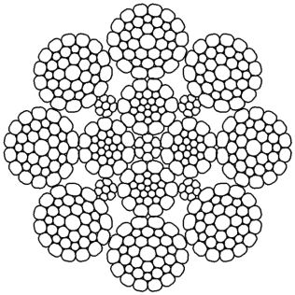

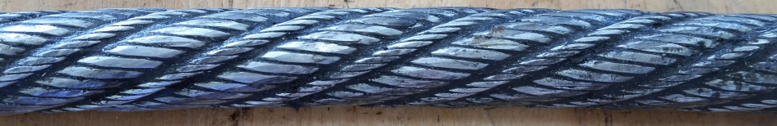**Figure 1:** Rope schematic and actual cross section (Style: Caption, Arial 10)

**Photo 2:** Rope schematic and actual cross section (Style: Caption, Arial 10)

# Main Heading(Style: Heading 1, Arial12, Bold)

Related text, tables, formulas and figures >>>>>>>>>>>>>>>>(Style Normal, Arial 12)

## Sub Heading (Style: Heading 2, Arial12, Bold, Italic)

Related text, tables, formulas and figures >>>>>>>>>>>>>>>>(Style Normal, Arial 12)

### Sub-sub Heading (Style: Heading 3, Arial 11, Bold)

Related text, tables, formulas and figures>>>>>>>>>>>>>>>>(Style Normal, Arial 12)

### Sub-sub Heading (Style: Heading 3, Arial 11, Bold

Related text, tables, formulas and figures>>>>>>>>>>>>>>>>(Style Normal, Arial 12)

*Any equations should be hanging by 2cm*

(1)



(2)



(3)



|  |  |  |  |  |  |
| --- | --- | --- | --- | --- | --- |
|  |  |  |  | | |
|  |  |  |  |  |  |
|  |  |  |  |  |  |
|  |  |  |  |  |  |
|  |  |  |  |  |  |

**Table 1:** Description of Table (Style: Caption, Arial 10)

Related text, tables, formulas and figures>>>>>>>>>>>>>>>>(Style Normal, Arial 12)

# Main Heading

|  |  |  |
| --- | --- | --- |
|  |  |  |
|  |  |
|  |  |
|  |  |
|  |  |

**Table 2:** Description of Table(Style: Caption, Arial 10)

Related text

# Conclusions(Style: Heading 1, Arial12, Bold)

Related text

# Acknowledgements(Style: Heading 1, Arial12, Bold)

# References(Style: Heading 1, Arial12, Bold)

[1] Reference 1 Numbered list of references used in the text, listed in the order in which they are first referred to (Style: References, Arial 12)

[2] Reference 2

Or in alphabetical order of surnames, for example:

Anderson L and Person M (1998): Wire rope research

Brown A (2021): Fibre rope research

# Author introduction

*The authors are strongly encouraged to add a short paragraph to introduce themselves to readers and audiences, but this item is not mandatory. The authors also have the option to choose text only introduction without providing photos.*

Abc D Example

**Mr/Ms/Mrs/Dr/Prof Abc D Example** received his/her BSc/Doctorate/PhD degree in Mechanical/Material Engineering from University of XXXX in 19XX. He/she started his/her professional career as a Rope Design Engineer at XXXX Company in 19XX, and then worked as a Rope Manufacturing Engineer at XXXX Company for 10 years. He/she has been an Application Specialist of Ropes at XXXX Institute of Technology for the past 20 years. His research interests are in Rope Ultrasound and Photoacoustic Imaging and spectroscopy and the development of new imaging technologies and image processing methodologies.

1. Corresponding author: email address